**English**

1st year

1. **Vocabulary: check this link quizizz.com/join?gc=558775 and play the game!** (Tienen tiempo hasta el jueves al mediodía)
2. **Complete the wordcross**

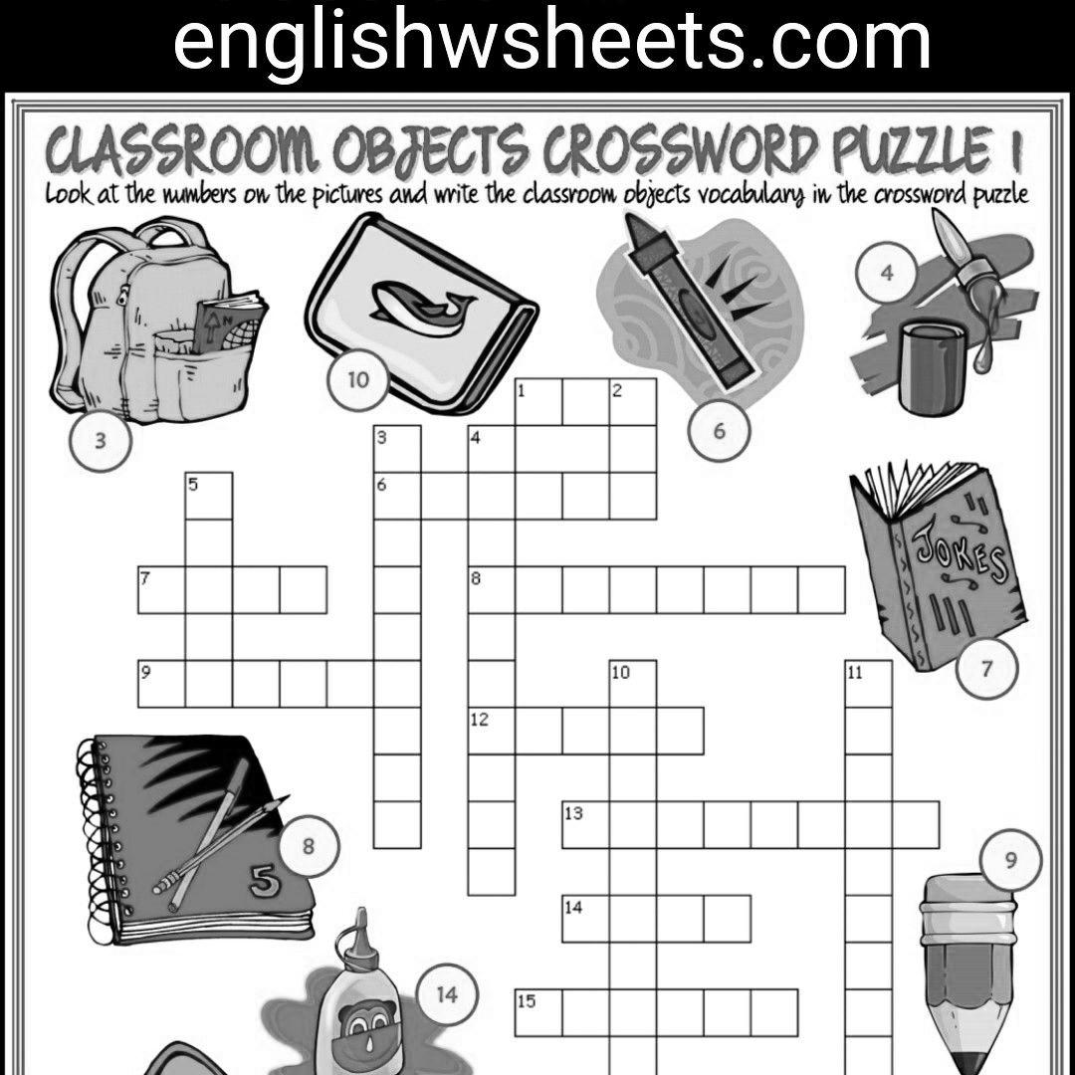

1. **Complete the sentences with school objects.**
2. My name is ………………….. In my schoolbag there are………………….,……………………………,…………………………..,……………………………
3. I have a ……………………………… for my pencils, pens, eraser and ruler.